**Project Design Phase-II**

**Data Flow Diagram & User Stories**

|  |  |
| --- | --- |
| Date | 26.06.2025 |
| Team ID | SWUID20250170870 |
| Project Name | Freelancing Application Mern |
| Maximum Marks | 4 Marks |

**Data Flow Diagrams:**

A **Data Flow Diagram (DFD)** for ORA illustrates how data moves through the social media platform. It represents how users interact with the system, including authentication, post creation, interactions (like, comment, save), and profile management.

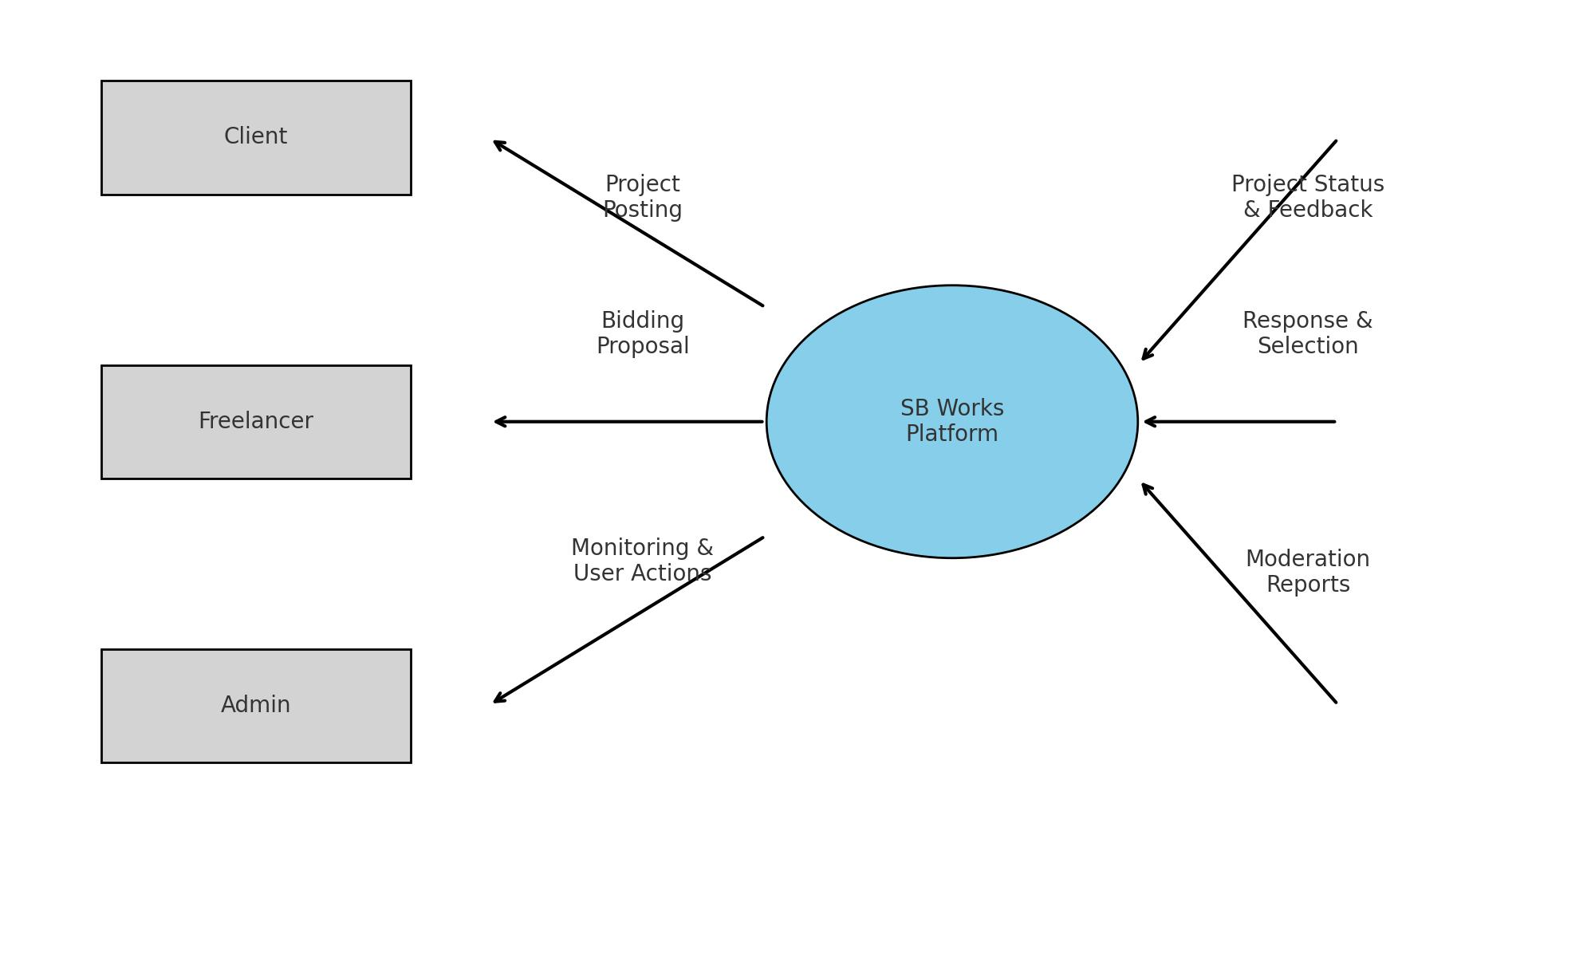

**User Stories**

**User Story Table – Ora**

|  |  |  |  |  |  |
| --- | --- | --- | --- | --- | --- |
| **User Type** | **Functional Requirement (Epic)** | **User Story / Task** | **Acceptance Criteria** | **Priority** | **Release** |
| Client | Project Creation | As a client, I can create and publish a project. | Project is listed on the  platform dashboard. | High | Sprint-1 |
| Freelancer | Project Exploration | As a freelancer, I can search and view  project details. | Search results match  specified criteria | High | Sprint-2 |
| Freelancer | Bid Submission | As a freelancer, I can submit a bid for a  Project. | Bid is visible to the client for  review. | High | Sprint-2 |
| User | Communication | As a user, I can exchange messages in  real-time. | Messages are delivered  instantly. | Medium | Sprint-3 |
| Freelancer | Profile  Enhancement | As a freelancer, I can update my skills  and portfolio. | Updates reflect immediately  on my profile. | High | Sprint-3 |
| Client | Work Acceptance | As a client, I can approve and process  payments for work. | Payment status updates in  transaction log. | Medium | Sprint-4 |
| User | Feedback System | As a user, I can provide feedback after  project completion | Feedback is displayed on  the freelancer’s profile. | Medium | Sprint-4 |
| Admin | Platform Oversight | As an admin, I can monitor and resolve  user disputes | Dispute actions are recorded  in logs. | High | Sprint-4 |